CS340 - Client/Server Development
Jared Harms
Oct 18, 2025
Project Two
Overview
To efficiently train rescue dogs for critical situations (water, mountain, and disaster rescue), Grazioso Salvare created this data-driven selection tool. It connects directly to the Austin Animal Center’s database, employing Plotly Dash and MongoDB to transform raw animal data into interactive tables, charts, and maps. This approach streamlines candidate selection by allowing staff to quickly visualize, filter, and identify the best dogs for each specialized rescue operation.
Project Functionality
The dashboard is powered by a secure CRUD connection to the MongoDB shelter database, loading all records into a dynamic table. Users can instantly filter the data using preset rescue categories (Water, Mountain, Disaster), with results visualized in real-time via a synchronized pie chart and geo-location map. The application’s interactive design links table selections directly to map markers for precise location identification, all while maintaining consistent corporate branding.
Tools/Framework
Tool / Library | Purpose | Rationale
MongoDB | Data storage (Model) | Handles semi-structured JSON-like documents.
PyMongo | Python driver for MongoDB | Provides simple CRUD operations and direct data access from Python.
Pandas | Data manipulation | Converts MongoDB documents into dataframes for Dash components.
Plotly Dash | Web framework (View + Controller) | Enables building rich, interactive dashboards directly in Python.
Dash Leaflet | Mapping component | Displays animal locations dynamically based on selected records.
Matplotlib / Plotly Express | Visualization libraries | Generate charts, such as pie charts.
JupyterDash | Runs Dash apps in Jupyter Lab | Allows live dashboard testing within the development environment.

System Architecture (MVC Pattern)
Layer | Technology | Description
Model | MongoDB via AnimalShelter CRUD class | Stores animal records and exposes CRUD operations for retrieval and filtering.
View | Dash components (tables, charts, map) | Presents data visually to the user.
Controller | Dash callbacks + CRUD module | Manages user interactions and updates dashboard elements dynamically.

Project Reproduction
A. System Setup
1. Install and start MongoDB: sudo systemctl start mongod
2. Load the Austin Animal Center dataset into the database (DB: aac, Collection: animals).
B. Project Files
Ensure the following files are in the same directory: CRUD_Python_Module.py, ProjectTwoDashboard.ipynb, Grazioso Salvare Logo.png
C. Run the Dashboard
1. Launch Jupyter Lab.
2. Open ProjectTwoDashboard.ipynb.
3. Run all cells in order.
4. The dashboard will appear in port 8050.
Testing and Verification
Test each filter (Water, Mountain/Wilderness, Disaster/Individual Tracking, Reset) and observe the updates in the data table, chart, and map.
Screenshots / Evidence of Functionality
Insert the four required screenshots here:
Figure 1: Dashboard Reset View 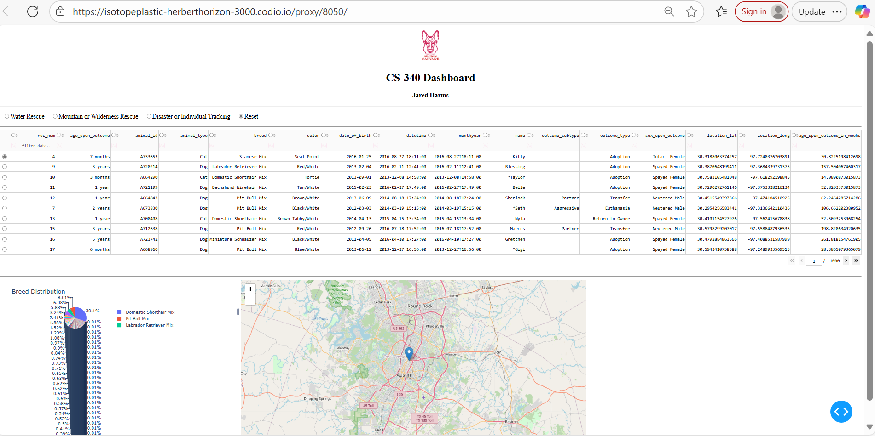

Figure 2: Water Rescue Filter Active 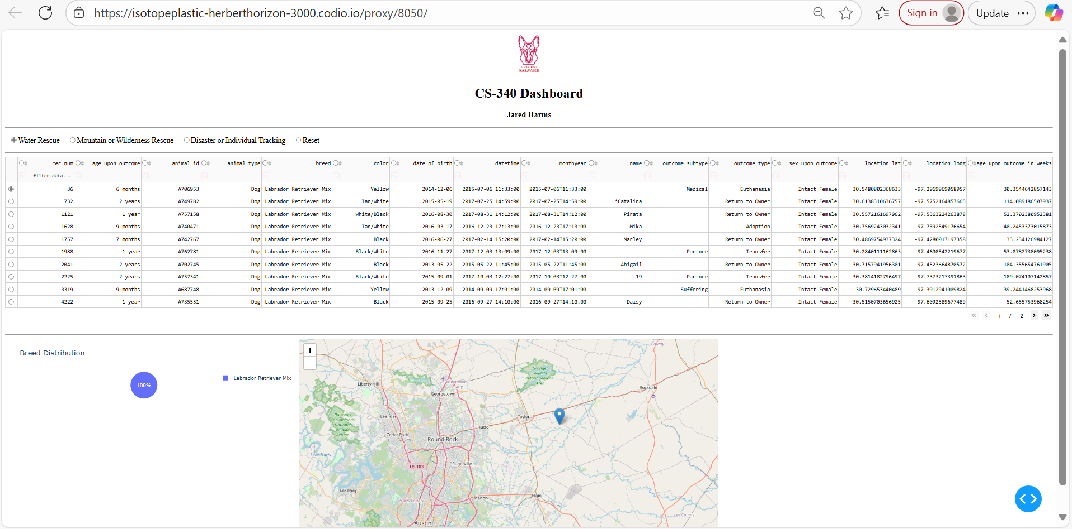

Figure 3: Mountain/Wilderness Filter Active 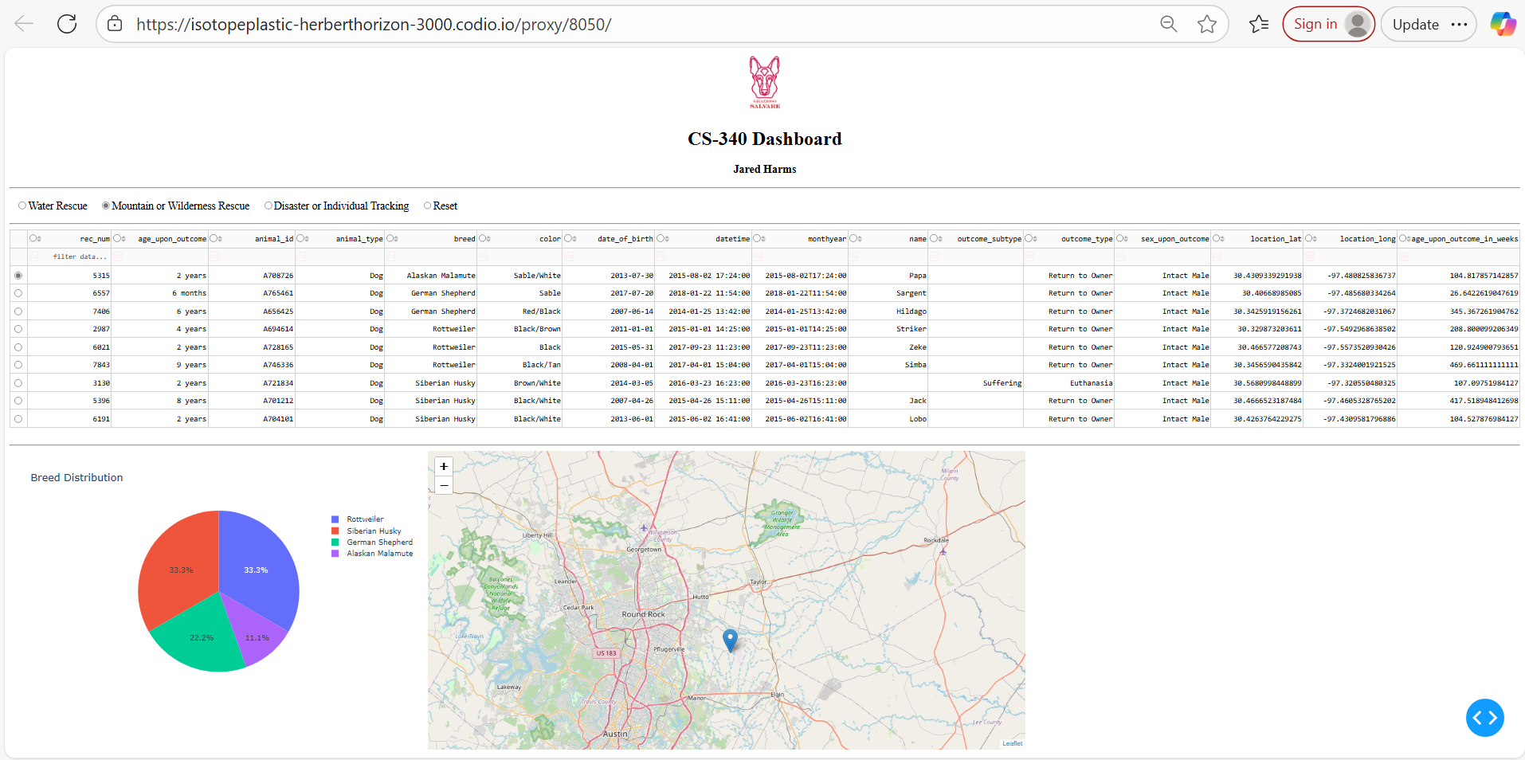

Figure 4: Disaster/Individual Tracking Filter Active
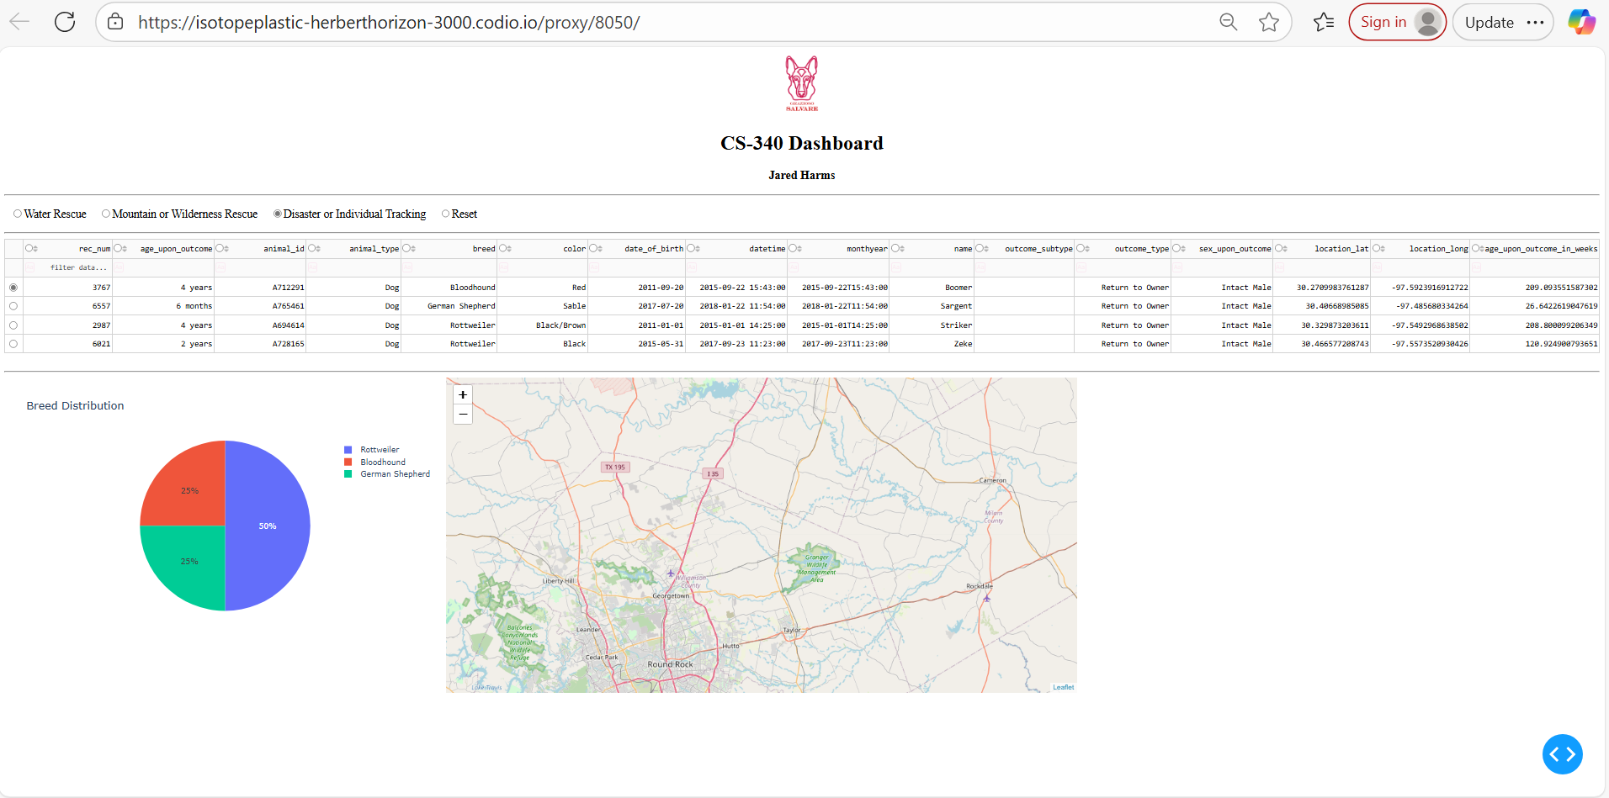

Challenges and Resolutions
Challenge | Resolution
Dashboard failed to connect to MongoDB | Adjusted the AnimalShelter constructor call to include all six parameters.
DataTable crashed due to ObjectId type | Dropped the '_id' column before displaying data.
Callbacks not updating properly | Verified correct Input/Output component IDs and ensured DataFrame conversion inside callbacks.
Map not displaying markers | Confirmed 'location_lat' and 'location_long' fields existed and used single-row selection for the map callback.

Reflection
This project demonstrates how full-stack Python development can merge data science and web application design. Using Dash with MongoDB created an agile, modular, and easily maintainable dashboard capable of real-time updates without reloading the page. The Grazioso Salvare dashboard transforms raw shelter data into actionable insights for rescue-dog training operations.
References
Austin Animal Center Outcomes (2020). City of Austin Open Data Portal. https://doi.org/10.26000/025.000001
Plotly Dash Documentation – https://dash.plotly.com
MongoDB Python Driver (pymongo) Documentation – https://pymongo.readthedocs.io
Dash Leaflet Documentation – https://dash-leaflet.herokuapp.com

